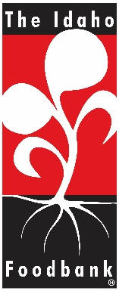
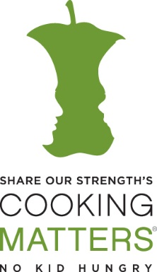
6- Week Cooking Matters Course

Insert Logo Here

Where: [Place], [Address]
When: Mondays | 10am-12pm | January 14th – February 25th

Please sign up if you are interested in joining us in a FREE cooking & nutrition class from (Your Organization), The Idaho Foodbank, and Share Our Strength! We will learn ways to select, cook, and purchase healthy foods while sticking to a budget. Participants will receive a book of tasty recipes and lessons on healthy foods, as well as graduation gifts after completing the course. This is a course is 6-week series; you must be able to attend at least four classes to graduate.
You must be able to provide your own transportation to and from the classes.
Name | Phone Number | Email Address
1.
2.
3.
4.
5.
6.
7.
8.
9.
10.
11.
12.
13.
14.
15.

Waiting List – You will be contacted if anyone is unable to attend this course.
Name | Phone Number | Email Address
1.
2.
3.
4.
5.
6.
7.
8.
9.
10.
11.
12.
13.
14.
15.
16.
17.

