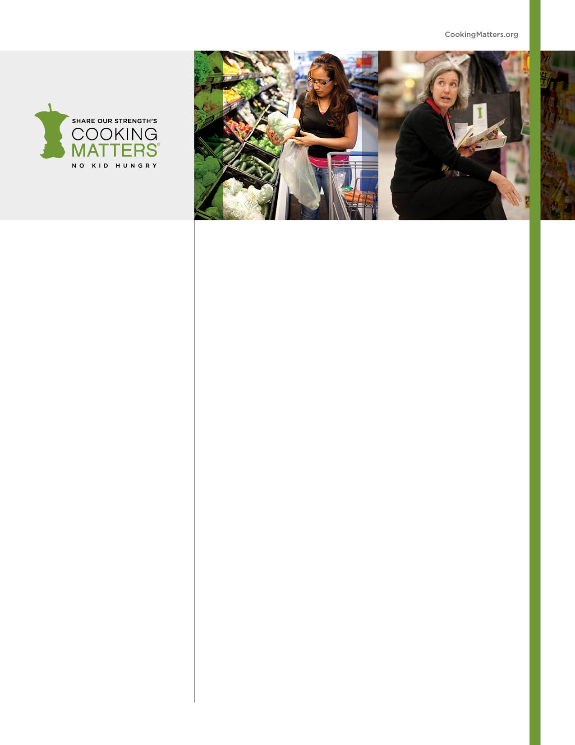

VOLUNTEER WITH COOKING MATTERS

Share Our Strength’s Cooking Matters program empowers families at risk of hunger with the skills, knowledge, and confidence to make healthy and affordable meals. Through hands-on classes taught by volunteer culinary and nutrition experts, course participants learn how to select nutrition and low-cost ingredients and prepare them as healthy and delicious meals.

**Volunteers:**

* Teach families how to prepare simple, nutritious, and delicious recipes
* Teach safe knife skills and food safety
* Help people make the most of their food budget and make healthy choices
* Expose participants to new foods and tasty ways to eat healthy on the go
* Use specialized skills and expertise
* Share passion for food and health
* Have fun, gain experience leading groups, fine-tune teaching skills and
* Make a difference!

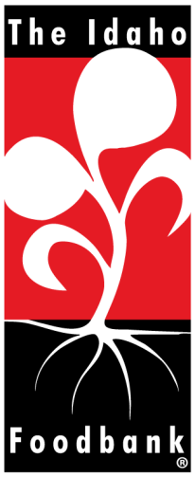

**VOLUNTEER OPPORTUNITIES:**

* Chef Instructor
* Nutrition Instructor
* Class Assistant
* Class Shopper
* Store Tour Leader
* Class/Tour Interpreter

**For more information on necessary skills, training,**

**and getting involved, please contact:**

Name:

Email:

Phone Number: