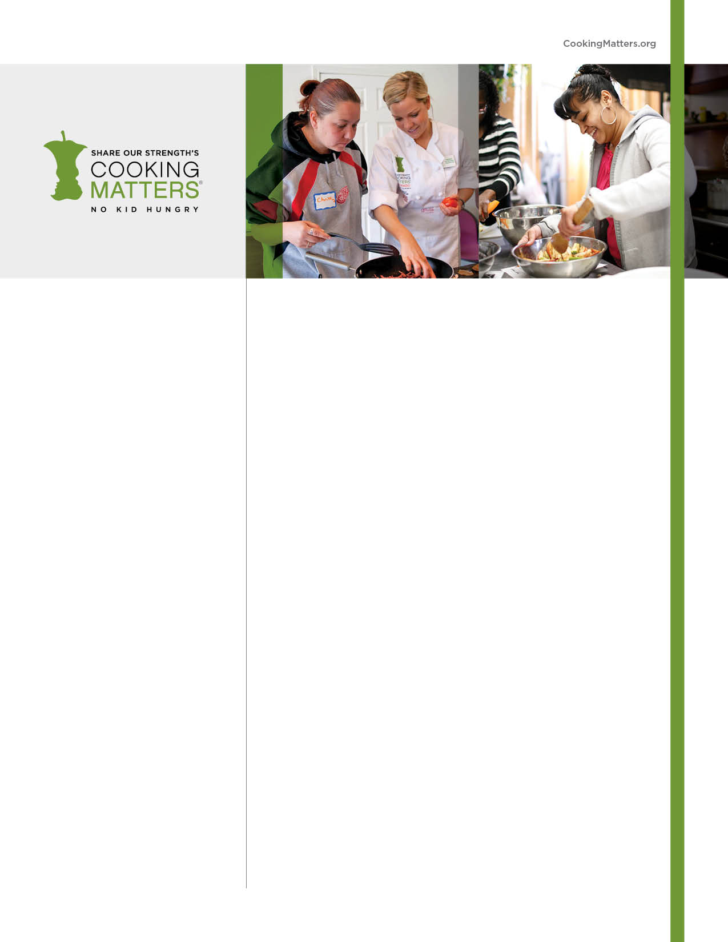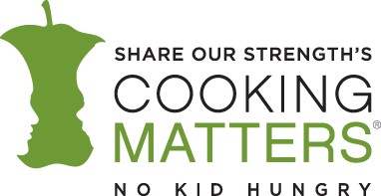

COOKING MATTERS FOR TEENS

Learn to cook healthy, affordable, and delicious meals!

Share Our Strength’s Cooking Matters™ teaches individuals and families how healthy cooking can be delicious, enjoyable—and most important—affordable.

Through this **FREE 6-week course** you can learn how to select nutritious and low-cost ingredients and prepare them in flavorful ways that provide the best nourishment for you and your family.

**Topics Include:**

* Cooking techniques, food safety, storage, and sanitation
* Preparing nutritious and delicious food on a budget
* Nutrition information to keep your family healthy
* Budgeting tips to stretch your food dollars and maximize your budget

**Each Week Participants Receive:**

* Hand-on culinary instruction from a chef and a shared meal with the class
* A bag of FREE groceries for adult participants to take home and prepare for their families while practicing the skills learned in class
* Recipe book, graduation certificate, and gift bag upon completion of the course

**Courses are open to households at or below 185% of the federal poverty level (about $3,747/month for a family of four).

Proof of income is not required.

**SIGN UP FOR A FREE COOKING CLASS!**

**DATES:**

**TIME:**

**LOCATION:**

**\*REGISTRATION REQUIRED\***

**To sign up, contact:**

*Host agency contact*

*phone*

*email*

*office location*



**Nationally Sponsored by:**

